RemoteConnectionProvider is in JBoss Remoting

JBoss Remoting uses XNIO to serve as server:

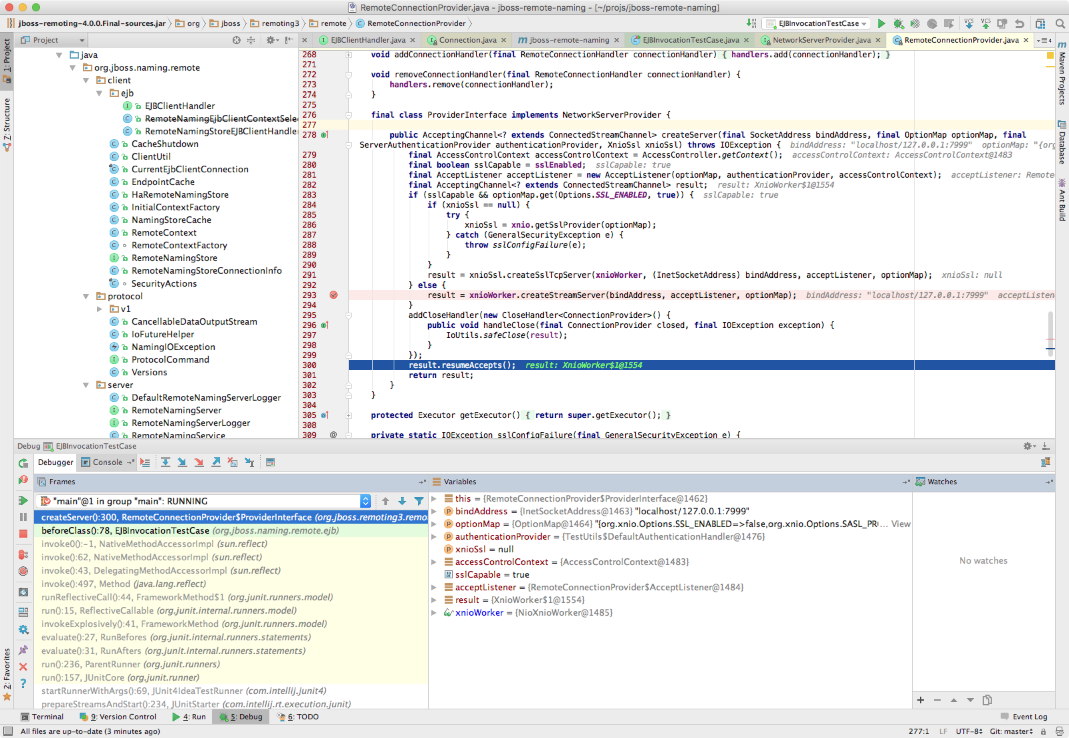

JBoss Remote Naming provides JNDI, and it uses JBoss Remoting

RemoteNamingService in JBoss Remote Naming provides the naming server:

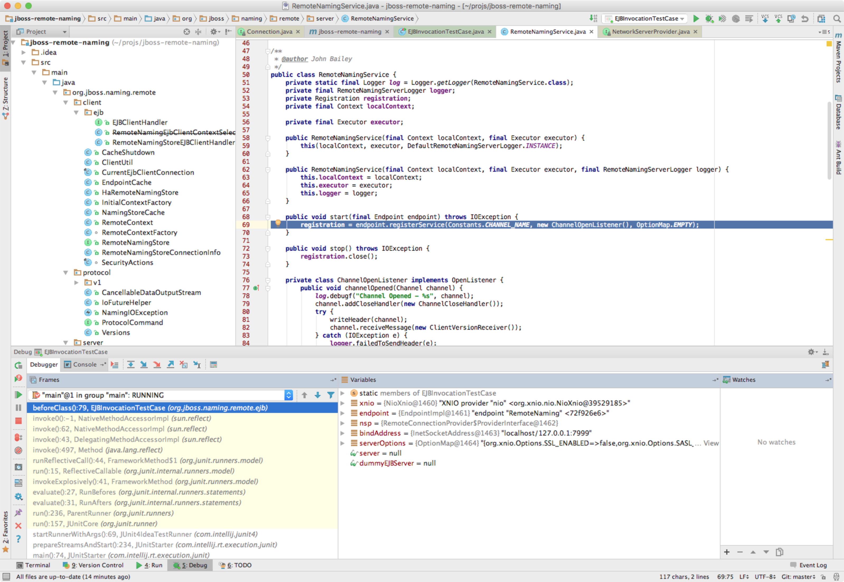

I should write something about XNIO

EJBInvocationTestCase is defined in jboss-remote-naming

DummyEjbServer worth reading in `jboss-remote-naming`:

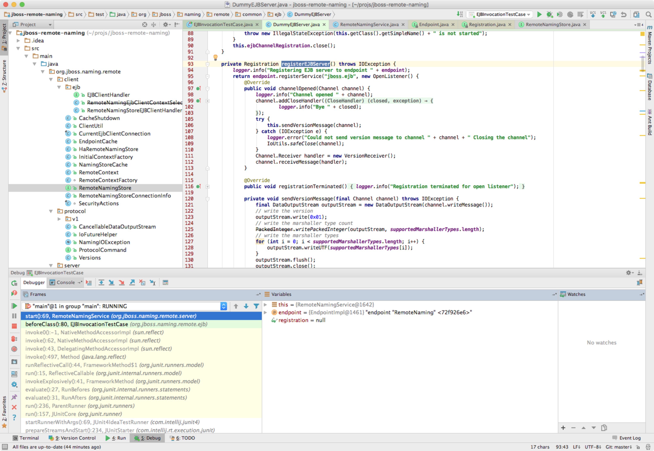

VersionReceiver.handleMessage:

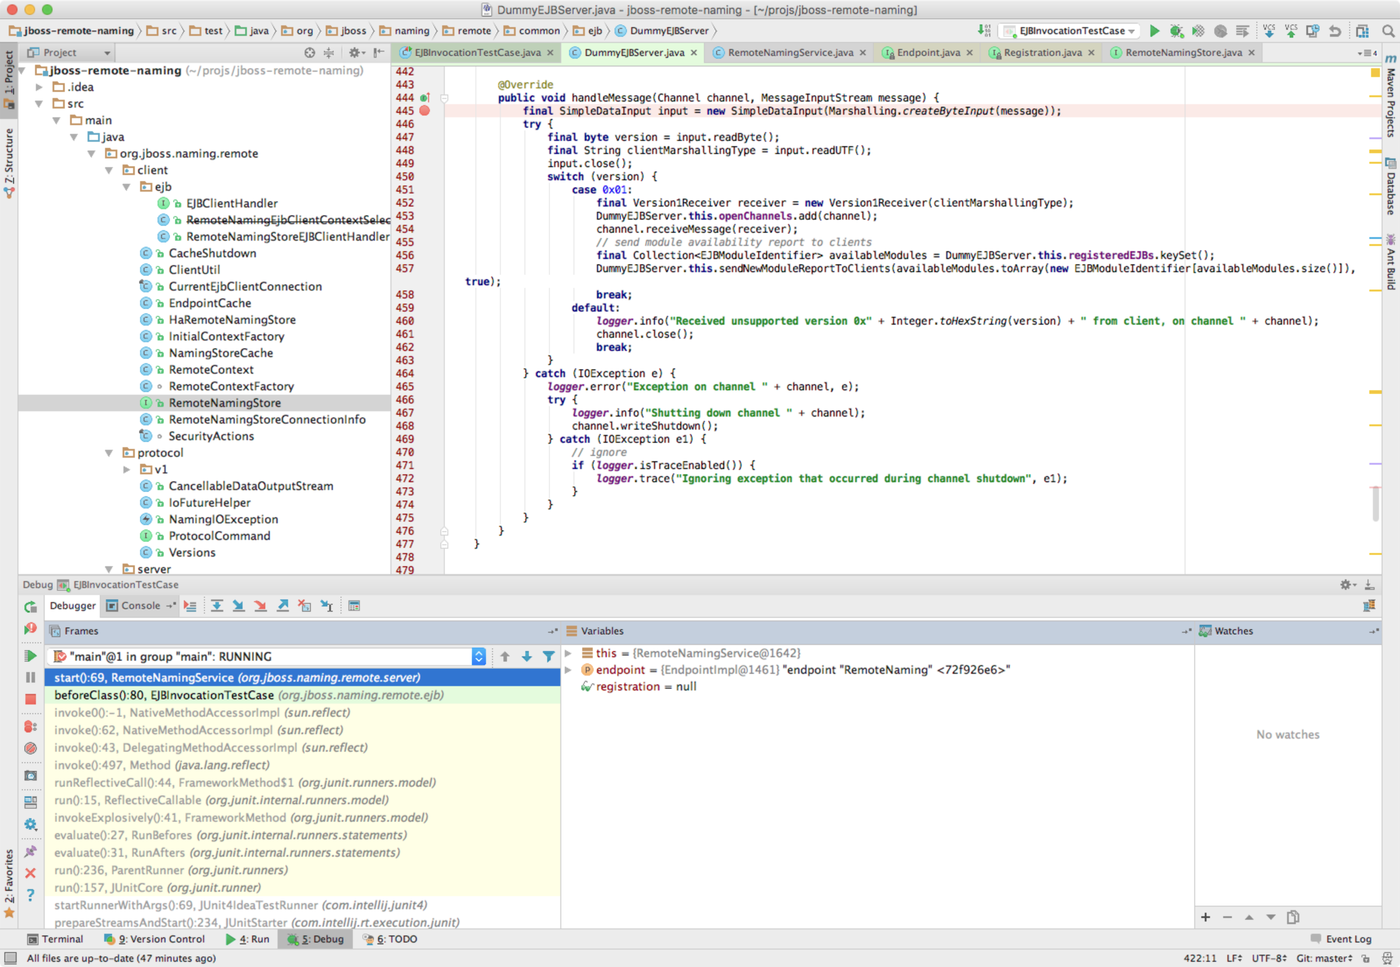

DummyEJBServer().registerEJBServer():

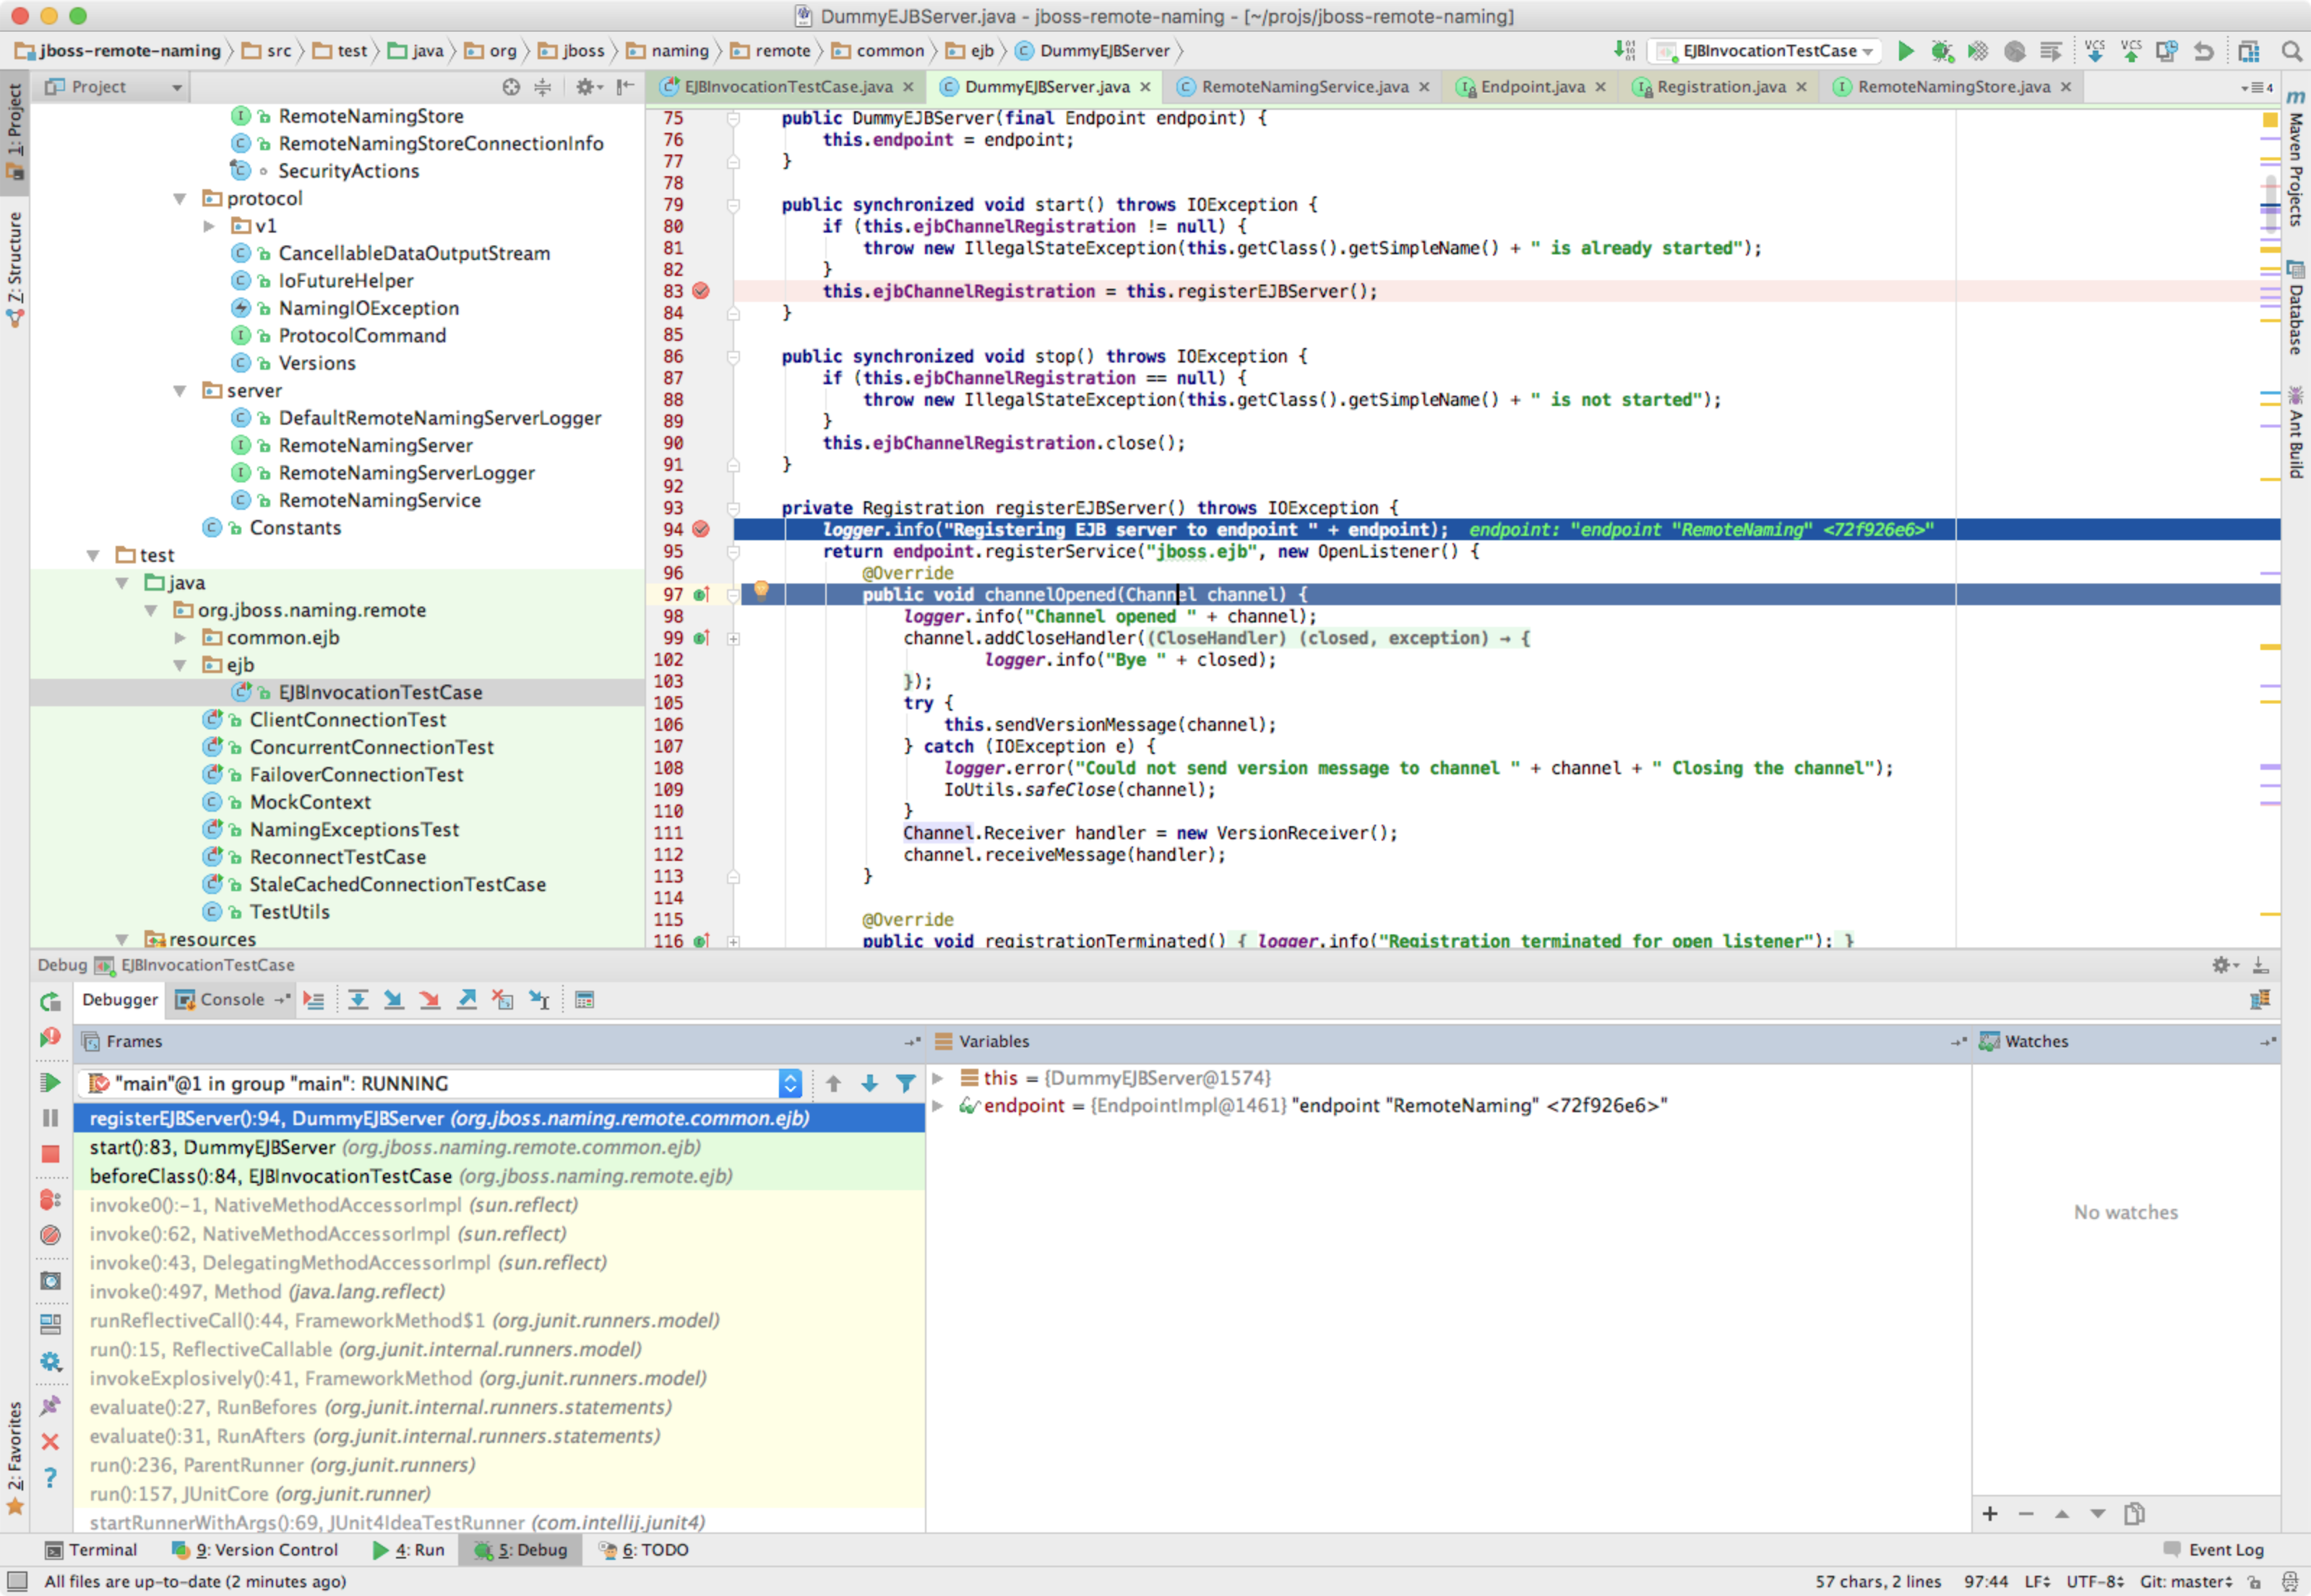

**return endpoint**.registerService(**"jboss.ejb"**, **new** OpenListener() {

